Nebu – DapresyPro Integration

Nebu setup
To setup the connection between Nebu and DapresyPro, first you need to login with your admin account to DubInterviewer.
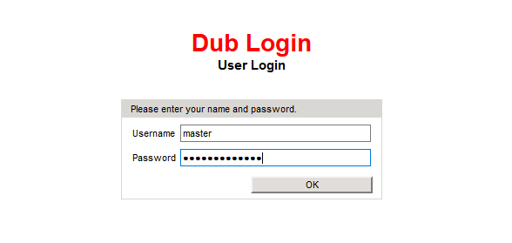
Once logged in, select project of interest and then click External Services.
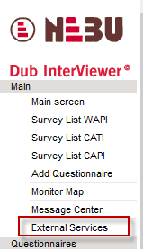
Choose the tab reporting providers and select to which DapresyPro installation you would like to connect. Contact your account manager at Dapresy if you are unsure of which one to use.
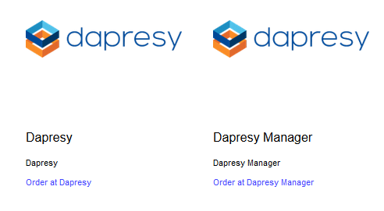
Click order at Dapresy and confirm with ok. This will create a report access URL at the top for the project you are in.
Click on the url and it will take you to the login screen of DapresyPro. Login with your regular admin credentials to the system and once logged in you will see a loading screen.
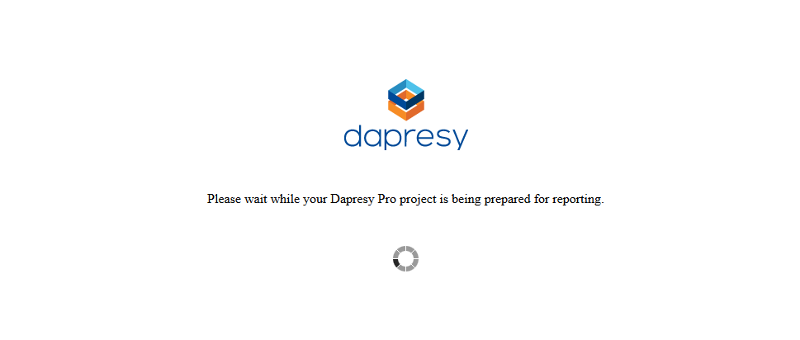
This indicates your project is being created and all data from the Nebu project is being created. This process may take up to a couple of minutes depending on the amount if variables and respondents.
When it has finished it will take you to the project directly.

Dapresy setup
Once the import part is complete you can now go ahead and setup your portal as normal. If you need to change or adjust the way data is being imported just go to the data scheduler page. The scheduler named Nebu Import is already created and connected to your Nebu project. By default it is set to import new data the 1st of every month. Go ahead and change the interval and settings if needed and re-save.
